Name: Angelo David B. Castuera

Course/ Yr. Level/ Block: BSCpE 2A

Subject: Software Design

**INDIVIDUAL PROGRESS REPORT**

**(STUDENT PROFILE SYSTEM)**

**MODULE: Displaying Information**

FLOWCHART:

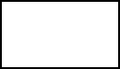

NO

YES

NO

YES

NO

Save Account

Enter Last Name:

First Name:

Username:

Password

Create Account

Stop

Update Last Name:

First Name:

Middle Name:

Course/ Yr. Level/ Block:

Add Student?

Student Profile System

Enter username & password

Do you have an account?

Log In

Start

Enter Last Name:

First Name:

Middle Name:

Course/ Yr. Level/ Block:

Stop

Save Information

YES

Display Last Name:

First Name:

Middle Name:

Course/ Yr. Level/ Block:

Edit Student?

Stop

END

DECISION TABLE

|  |  |  |  |  |  |
| --- | --- | --- | --- | --- | --- |
| Last Name | T | F | F | F | T |
| First Name | F | T | F | F | T |
| Middle Name | F | F | T | F | T |
| Course/Yr. Lvl/Blk | F | F | F | T | T |
|  |  |  |  |  |  |
| Actions |  |  |  |  |  |
| Display | F | F | F | F | EXECUTE |

DFD (DATA FLOW DIAGRAM)

Last Name:

First Name:

Username:

Password:

Registration

Last Name:

First Name:

Username:

Password:

Username:

Password:

Database

Log In

First Name:

Middle Name:

Course/ Yr. Level/ Block:

User

Input

First Name:

Middle Name:

Course/ Yr. Level/ Block:

Database

Display

First Name:

Middle Name:

Course/ Yr. Level/ Block:

HIPO (VTOC)

1.5

Displaying

Information

1.5.2

Log In

1.5.3

Inputting Information

1.5.1

Registration

ACTIVITY DIAGRAM

Input Information

Students

Information

Incomplete Information

Display Information

Complete Information

IPO

Module No. Date: 05-31-22

Name: Displaying of Information Prepared by: Angelo David B. Castuera

Description: Displays information from user input

|  |  |  |
| --- | --- | --- |
| Input | Process | Output |
| **Student Information:**  Last Name  Given Name  Middle Name  Course/Yr. Level/Block | Add to Database | Display Information |

USE CASE:

Registration

Log In

Input

User

Display

Sequence Diagram

Displaying Information

USER

User Input

Last Name

Given Name

Middle Name

Course/Yr. Level/Block

Display

Last Name

Given Name

Middle Name

Course/Yr. Level/Block

Class Diagram

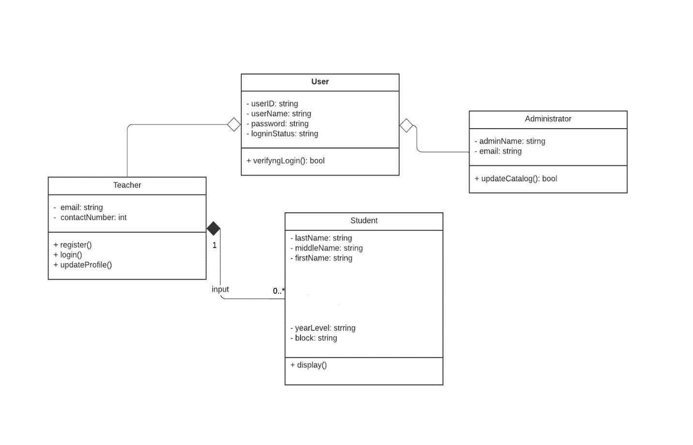

Entity Relationship Diagram

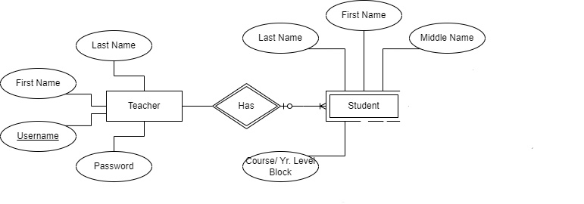

Database Normalization

StudentsInformation (blockName, studentID, lastName, givenName, middleName,)

Students Information

|  |  |  |  |  |  |  |  |  |  |  |  |
| --- | --- | --- | --- | --- | --- | --- | --- | --- | --- | --- | --- |
|  |  | | |  | |  |  | |  | |  |
| Student ID | | Last Name | Given Name | | Middle Name | | | Course/ Yr. Level/Block | |
| 123456 | | Dalisay | Ricardo | | Borja | | | BSCpE 2A | |